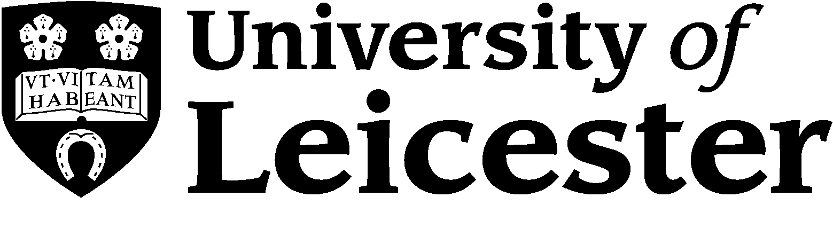 | International Office

Erasmus+ Student Traineeship

Title: International Office Erasmus Trainee
Department: International Office, University of Leicester
Responsible to: Mr Peter Hough, Senior International Officer (Mobility and Exchange)
Hours of work: 35 hours per week (Office hours are Monday-Friday 09:00-17:00)
Salary: Unpaid.
Benefits: University accommodation will be provided free of charge, as well as a bus pass for the local area. We will also provide a lunch card at £5 per working day.
Holidays: 2 days per month of work
Dates: July/August-November 2015, subject to candidate availability

Main purpose:

This is an opportunity for a motivated European student to gain familiarity in a British working environment and to build on their English language skills in a professional setting. The main purpose is to gain experience of working in the Erasmus and Study Abroad Teams at the University of Leicester. During this time you will gain an overall knowledge of the responsibilities in the teams as well as an in-depth knowledge of the Erasmus+ exchange programme.
Main duties:

- Supporting the Erasmus and Study Abroad Teams on various aspects of the administration of the Erasmus+ programme, including promotion, record-keeping, monitoring and event organising
- Contributing to the development and improvement of the Erasmus programme
- Using and developing day-to-day systems for data storage and reference
- Conducting online research related to European partner universities and destinations
- Processing Erasmus+ paperwork for University of Leicester students
- Providing additional support for International Officers during busy periods
- Undertaking other relevant duties as a part of the wider team in the International Office

Qualification, knowledge, experience and skills required:

Essential
- Completed at least two years of university study*
- A working knowledge of English language (as a second language)*
- Flexibility to perform a range of tasks, including basic administrative work
- Good written* and spoken communication skills, and the ability to communicate effectively with people whose first language is not English
- Computer-literate: competent in the use of Excel, Word and electronic communications
- Good interpersonal skills.
- Cultural awareness and sensitivity to deal with international students.

Desirable
- Knowledge of a third European language

(*Criteria to be used to shortlist candidates for interview)

The University

The University of Leicester is a leading UK University committed to international excellence through the creation of world changing research and high quality, inspirational teaching. Leicester is consistently one of the most socially inclusive of the UK’s leading universities with a long-standing commitment to providing fairer and equal access to higher education.

We are described as "elite without being elitist". We are proud to be elite. But we are at least as proud to be an inclusive and progressive university. We are one of the most inclusive of Britain's leading universities. This commitment to high quality, an inclusive academic culture and belief in the synergy of teaching and research are our hallmarks. We believe that teaching is inspirational when delivered by passionate scholars engaged in world-changing research that is delivered in an academic community that includes postgraduate as well as undergraduate students.

We believe that teaching and research are synergistic, and the National Student Survey demonstrates that the quality of our teaching is amongst the highest in the country.

Our Standing
The University of Leicester was the THE University of the Year 2008-9. In awarding the title the judges cited Leicester’s ability to “evidence commitment to high quality, a belief in the synergy of teaching and research and a conviction that higher education is a power for good”. Leicester was, said the judges, "elite without being elitist".
We’re highly ranked in major national UK tables including:
- 18th in the Times Higher Table of Tables
- 20th in The Times/Sunday Time Good University Guide
- 24th in the Complete University Guide
- Leicester is ranked in the top 2% of universities in the world by both the QS World University Rankings 2011, Taiwan World University Rankings and THE World University Rankings.
The University has won Times Higher Awards in 2007, 2008, 2009, 2010, 2011, 2012, 2013 for its work in innovation and technology. It is the only university to win seven consecutive awards.
The International Office
The International Office leads and co-ordinates activity to ensure the University reaches its international student targets in the short-term and develops longer-term sustainable approaches to recruitment through diversification of markets and recruitment channels. It achieves this whilst seeking to improve the academic quality of the intake. Its work enhances the profile of the University internationally through relationships and partnerships. It works with other parts of the University to ensure the international student experience remains positive and continues to improve.
More information:
Ms Nalina Pattni, Erasmus Assistant
+44 116 252 5142
erasmus@le.ac.uk

How to apply: Please fill out the attached application form and return to the above email address.

Closing date for applications: Tuesday 7th July 2015, midnight Greenwich Mean Time.
Skype or phone interviews have been planned for Wednesday 15th July.

